Question 01.

Question 02.

Question 03.

Question 04.

package q04;

public class **BankingSystem** {

public static void main(String[] args) {

SavingsAccount savingsAccount01 = new SavingsAccount("SAV001","Sumana Galappaththi",32500);

CurrentAccount currentAccount01 = new CurrentAccount("CURR001","Ajith Muthukumarana",65000);

currentAccount01.setCreditLimit(9500);

currentAccount01.displayAccountDetails();

savingsAccount01.withdraw(100);

savingsAccount01.displayAccountDetails();

currentAccount01.withdraw(100);

currentAccount01.displayAccountDetails();

savingsAccount01.deposit(6500);

savingsAccount01.displayAccountDetails();

currentAccount01.deposit(7500);

currentAccount01.displayAccountDetails();

savingsAccount01.applyInterest();

savingsAccount01.displayAccountDetails();

currentAccount01.withdraw(5000);

currentAccount01.displayAccountDetails();

currentAccount01.withdraw(35000);

currentAccount01.displayAccountDetails();

}

}

package q04;

public class **CurrentAccount** extends **Account**{

double creditLimit ;

public CurrentAccount(String accountNumber, String accountHolderName, double balance) {

super(accountNumber, accountHolderName, balance);

}

public void setCreditLimit(double creditLimit) {

this.creditLimit = creditLimit;

}

public void withdraw(double amount){

if (amount<=creditLimit){

System.out.println("Withrawn Successfully "+amount);

super.balance-=amount;

} else {

System.out.println("Credit Ammount Exceded");

}

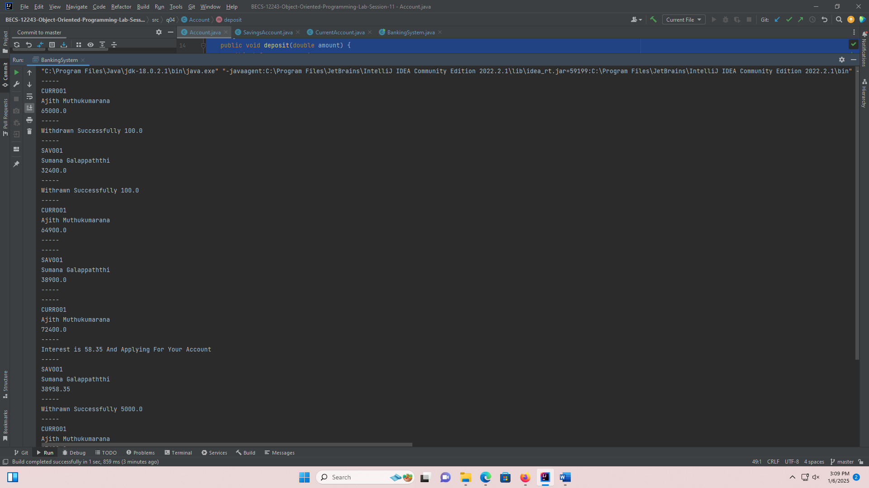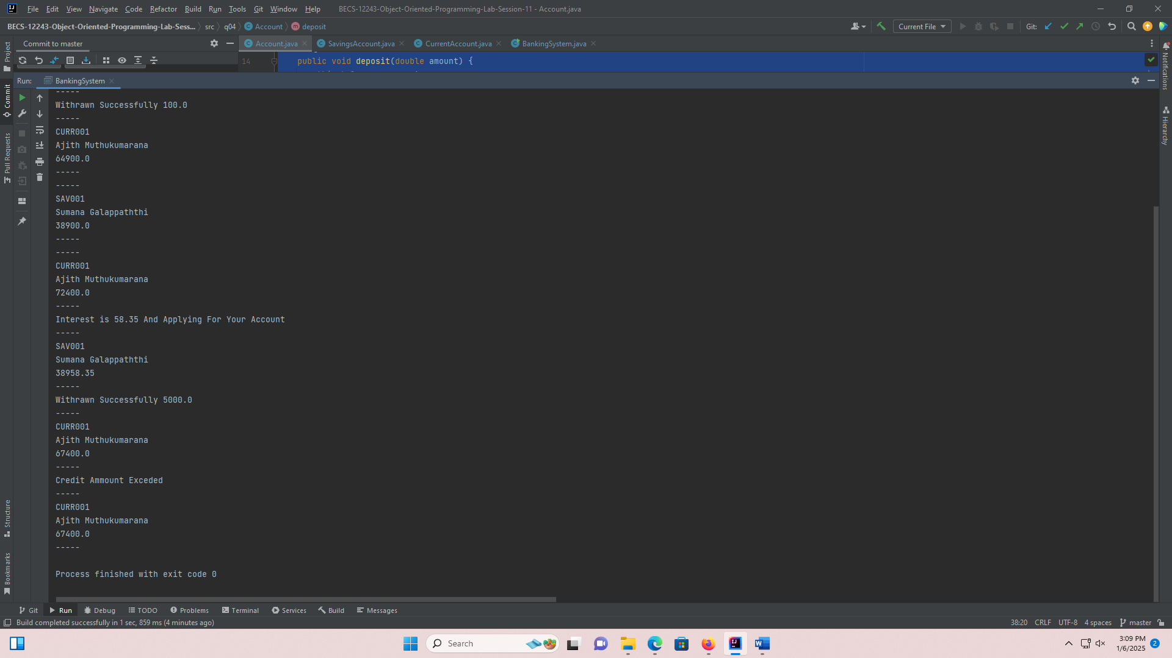 }

}

package q04;

public class **SavingsAccount** extends **Account** {

double interestRate = 0.15;

public SavingsAccount(String accountNumber, String accountHolderName, double balance) {

super(accountNumber, accountHolderName, balance);

}

public void withdraw(double amount){

if (super.balance >=0){

System.out.println("Withdrawn Successfully "+amount);

super.balance -= amount;

} else {

System.out.println("Insufficient Balance");

}

}

public void applyInterest(){

double Interest = balance * interestRate / 100;

System.out.println("Interest is "+Interest+ " And Applying For Your Account");

super.balance += Interest;

}

}

package q04;

public class **Account** {

protected String accountNumber;

protected String accountHolderName;

protected double balance;

public Account(String accountNumber, String accountHolderName, double balance) {

this.accountNumber = accountNumber;

this.accountHolderName = accountHolderName;

this.balance = balance;

}

public void deposit(double amount) {

this.balance +=amount;

}

public void displayAccountDetails() {

System.out.println("-----");

System.out.println(accountNumber);

System.out.println(accountHolderName);

System.out.println(balance);

System.out.println("-----");

}

}

Question 05.

package q05;

public class **Calculator** {

public static void main(String[] args) {

Addition add = new Addition();

Subtraction sub = new Subtraction();

Division div = new Division();

System.out.println(add.Addition(5, 7));

System.out.println(add.Addition(5.0, 7));

System.out.println(add.Addition(5, 7.0));

System.out.println(add.Addition(5.0, 7.0));

System.out.println(sub.Subtraction(95,15.5));

System.out.println(div.Division(5,0));

System.out.println(div.Division(15,0.5));

}

}

package q05;

public class **Subtraction** {

public int Subtraction(int a, int b) {

return a - b;

}

public double Subtraction(double a, double b) {

return a - b;

}

public double Subtraction(int a, double b) {

return a - b;

}

public double Subtraction(double a, int b) {

return a - b; }

}

package q05;

public class **Addition** {

public int Addition(int a, int b) {

return a + b;

}

public double Addition(double a, double b) {

return a + b;

}

public double Addition(int a, double b) {

return a + b;

}

public double Addition(double a, int b) {

return a + b;

}

}

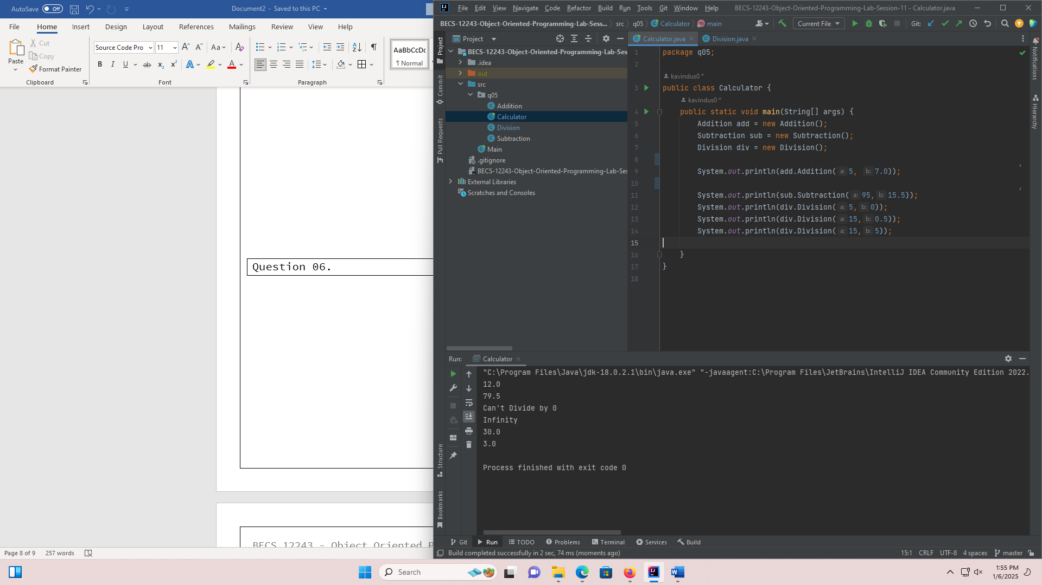

package q05;

public class **Division** {

public double Division(int a, int b) {

if (b==0){

System.out.println("Can't Divide by 0");

} else

return (double)a / b;

}

public double Division(double a, double b) {

if (b==0){

System.out.println("Can't Divide by 0");

} else

return a / b;

}

public double Division(int a, double b) {

if (b==0){

System.out.println("Can't Divide by 0");

}else

return a / b;

}

public double Division(double a, int b) {

if (b==0){

System.out.println("Can't Divide by 0");

}else

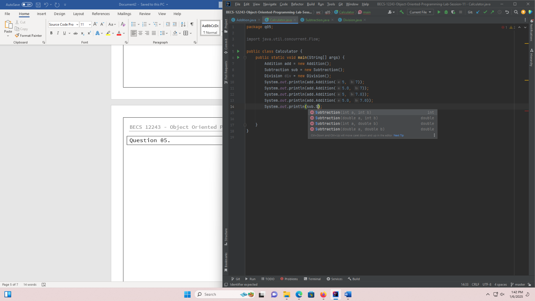 return a / b;

}

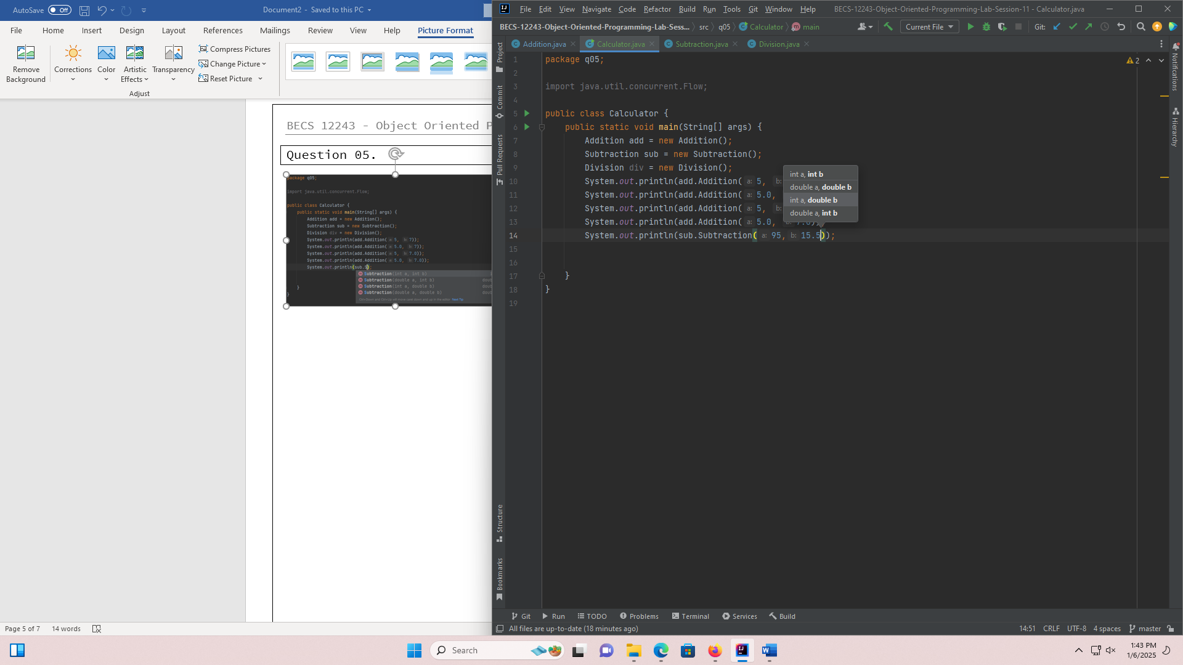}

Question 06.

package q06;

public class **StringManipulator** {

public static void main(String[] args) {

StringManipulator str = new StringManipulator();

System.out.println(str.reverse("HelloWorld"));

System.out.println(str.reverse("HelloWorld",3));

System.out.println(str.reverse("HelloWorld",2,9));

}

public String reverse(String s){

StringBuffer sbf = new StringBuffer(s);

sbf.reverse();

return s;

}

public String reverse(String s, int n){

StringBuffer sbf3 = new StringBuffer(s);

String subs = sbf3.substring(0,n);

StringBuffer sbst = new StringBuffer(subs);

sbst.reverse();

return subs;

}

public String reverse(String s, int start, int end){

StringBuffer sbf3 = new StringBuffer(s);

String subs = sbf3.substring(start,end);

StringBuffer sbst = new StringBuffer(subs);

sbst.reverse();

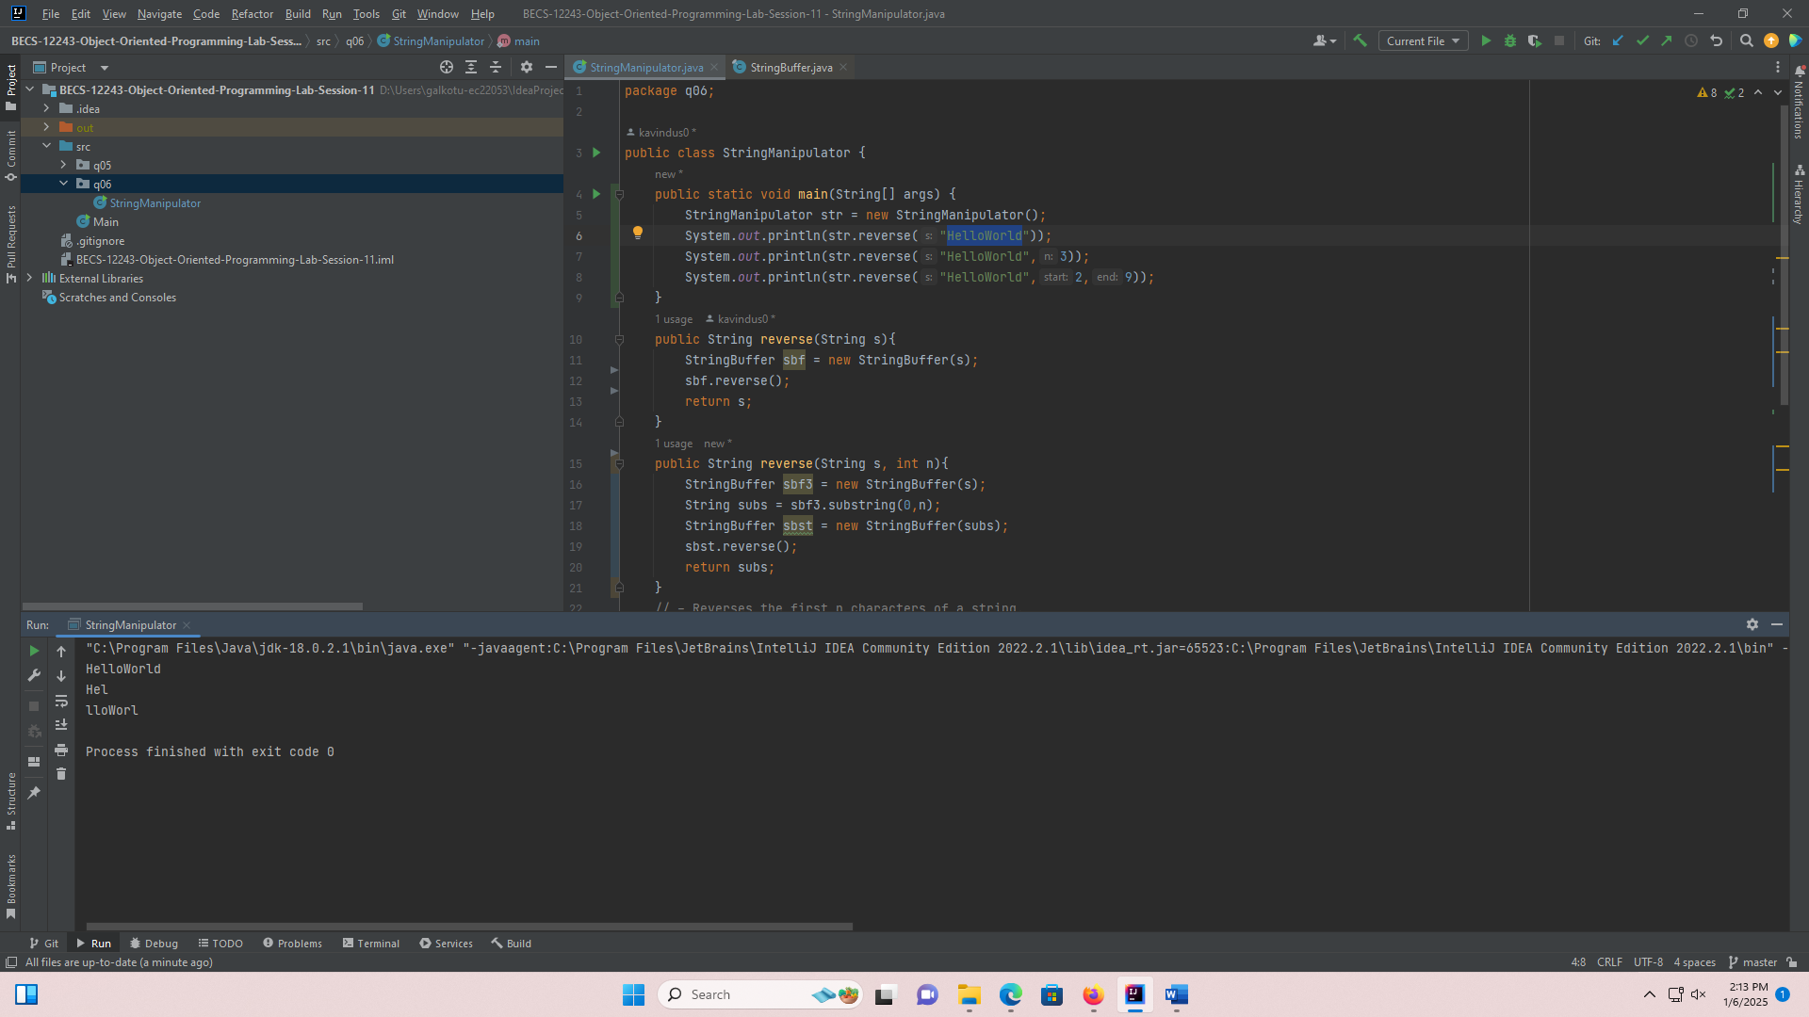 return subs;

}

}